Introduction to Geographic Information Systems (GIS)

Week 02

**Getting Started**

This week we will start using ArcGIS Desktop and introduce most of the basic techniques for creating, manipulating, navigating, annotating and saving maps. If you are planning to use ArcGIS Desktop on your computer, install ArcGIS ArcMAP

***Installation***

For installallatioon on your own machine (Windows only) follow the instruction in the “Installation” document in the Course Information Section of Blackboard

***Screen Videos***

To support the exercises, I have created “step-by-step” videos. The videos are embedded in Blackboard using the “Kaltura” application. This week there are 3 videos:

1. Directory structure and working with Zip files (note comment below)
2. Introduction to ArcMap: base maps, navigation, saving
3. Introduction to Cartography: making the maps presentable (labels, title,legend, north arrow, scale)

**IMPORTANT:**

* ***Some of the mapping assignment videos may have been made in a previous semester and so in the instructions, some of the files and filenames that are date or semester dependent will not reflect Fall 2019 but rather, for example, Fall, 2017 or 2018. Make sure you name files and directories according to the instructions below.***
* ***When the videos, because of the software version, are confusing, I will re-do them. This semester we are using ArcMap 10.7.1, earlier versions of ArcMap 10 (e.g. 10.4) will work fine***

***Setting up the directory structure on your computer.***

At some point, I may be asking you zip the folder with your map data and send to me so that I can look at it. In order to do this, you will have to make sure the directory structure on your home computer matches the directory structure indicated below.

Note: the actual names of your directory and week number folders should be done as you see below **(NOTE: the video may use a slightly different naming convention).**

1. Create a directory structure off your main drive (this can be either any drive you will use for data (even a Flash Drive). Be sure to use the naming convention illustrated below:

*X:* \lastname\WEEKnumber

For example for me: c*:\farkas\week02*

*Note that it is all lowercase.*

1. In the above example:
   1. X: is the main or data drive on your computer
   2. ***lastname*** is your personal directory
   3. ***week02*** is a directory that holds the exercises for the current week:
2. When building your weekly exercise, place all data files in the folder for the current week

**IMPORTANT: The files must be in the directory structure above for me to see them when I copy them to my computer to look at your GIS models.**

***Submitting Assignments and Filenames***

Submissions will be of 2 types (the instructions will tell you how to do it):

1. Exported map images that are cut and pasted into MS Word and then uploaded as an assignment. In Blackboard, I will create the “assignment link” in the folder for the week. Make sure that each file submitted is properly identified otherwise it may not be graded. You should name all files beginning with your last name, the week, and assignment name. For example a word document for Week02 might have the name: *farkasweek02map02.doc*
2. Another type of export is using a PDF which will allow one to see the map layers (you will understand what this is when we get to it). These will be uploaded to Blackboard in the appropriate assignment link as well and should also use the naming format:

*farkasweek02map02.pdf*

Assignments that don’t use the proper name may not get graded (I won’t see it)!

***Working with Zip Files***

Many of the data files we use will come from the Internet and are packaged as zip files. You can use the built in “zip” handling of your operating system, or download a demo version of WinZip (45 days) from [*http://www.winzip.com*](http://www.winzip.com)*.*

Simplest way with Windows:

1. Right click the zip file
2. Select “Explore” or “Open” or “Extract all” or “7-Zip “(depends on which version of Windows you are using).
3. This opens a folder with the files in the zip file
4. Copy the files you see into the same directory as the zip file you are opening. *In other words, all the files should be in the folder for that week.*

***Working with ArcGIS Desktop: ArcMap***

In this week’s assignment, I have downloaded the files we need (in later assignments you will get them from the Internet on your own). The files are in the folder for this week.

1. On your main data drive or if you are working in a lab on a portable drive (USB), create the directory structure as indicated above (you may not be able to get credit for assignments if the directory structure on your computer doesn’t match the one above.
2. Create the folder for this week. For example, my folder on my computer would be:

C:\farkas\week02

1. From the Course Documents folder for Week 02, download the zipfile into the folder on your computer. This file contains 6 other zip files that contain the map files. Unzip all the files. It should look like the following. Don’t worry about the file icons (to the left of the name). The drive letter will be based on your computer

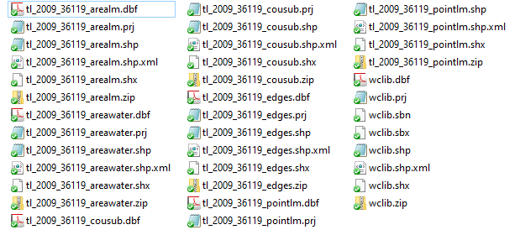

1. Start ArcMap (Start Menu->ArcGIS->ArcMap). You may have to close a dialog box asking to open an existing project.

s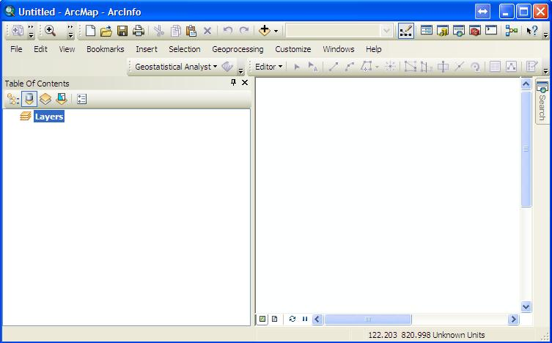

1. For administrative purposes (so you can zip a folder and send it to me), we want to set the Pathnames to be relative. Go to File->Map Properties-> and check the Pathnames box at the bottom of the dialogue box.

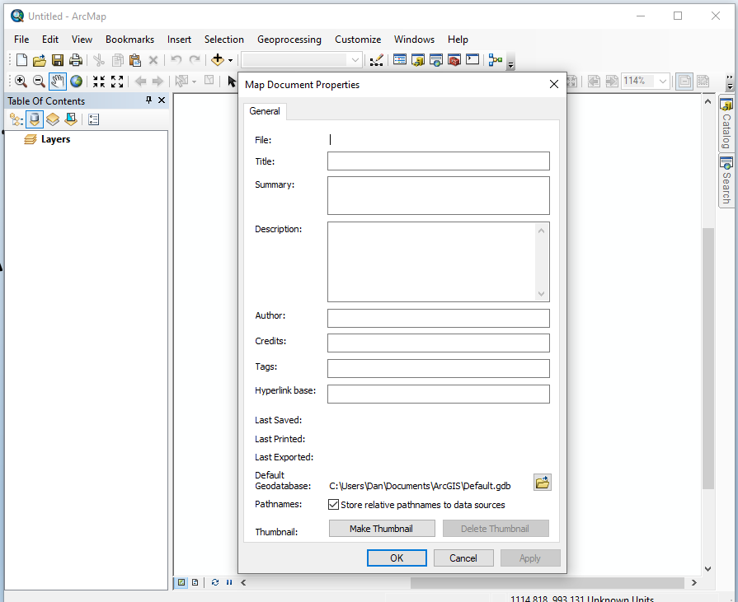

1. Choose the “+” yellow icon at the top (or File->Add Data->Add Data…).
2. Before navigating to your folder (e.g. C: \farkas\week02), you may have to create a connection to your folder.
   1. Go to the Folder Connections folder
   2. Select the Create Connection icon (it looks like a folder with little + signs)
   3. Navigate to the folder that has your last name and click ok. You should see your weekly folder (week02). This will make your folders visible when you go to access them.
3. Once you added the “connection”, you go to Folder Connections and should see the folder with your last name. Select it to see your weekly folders (only week02 for now). Also, if your main drive is “C:” you will see that instead of the USB drive.

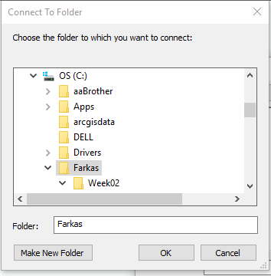

1. Expand Week02 and highlight the shapefiles (except for the wclib.shp) and click “Add”. A Westchester map should appear with all 5 layers. (You can also add the files one-by-one).

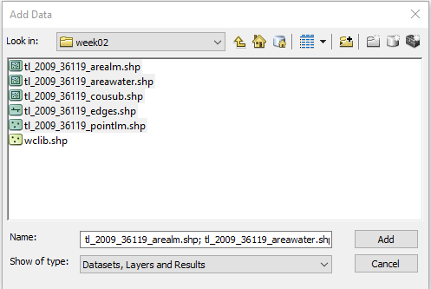

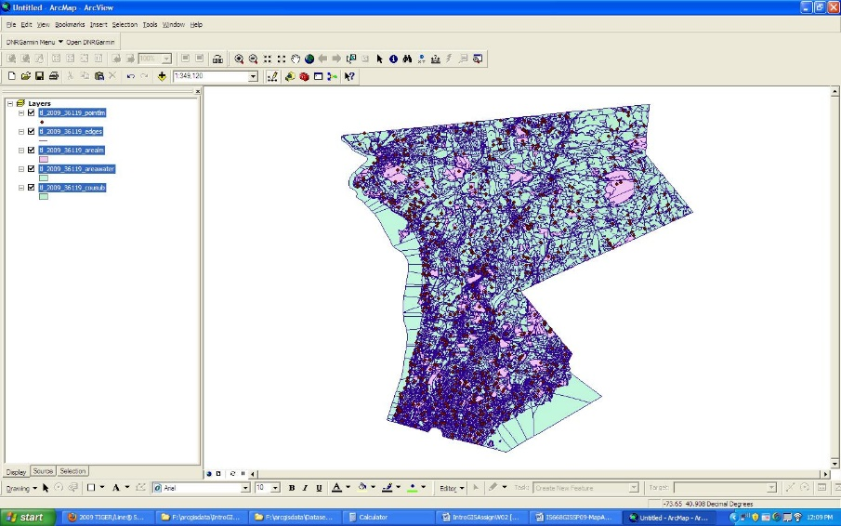

1. Note. The colors of your map may be different.
2. Create a JPEG of the map Image
   1. Go to the File menu at the top
   2. Select Export Map
   3. Make sure the file type is JPEG
   4. Name the file *yourlastname*week02westchester01.jpg
   5. Save to your week02 folder
3. Create a pdf of the map image
4. Follow the above steps, but select file type PDF. We’ll look at it later.
5. Experiment in ArcMap by turning layers on and off by toggling the check boxes on the left (instructions in the video).

***Saving Maps created by ArcMap (.mxd)***

1. Now save the map file (.mxd). Go to File🡪Save. Make sure you put it the directory structure as indicated above. The map that is saved does not contain the data in the map, but rather the information in the map describes where the data is as well how to display the map. All maps and data should be in the same directory. Name the map:

*yourlastnameWeek02Map01.mxd*

***Navigating in ArcMap (Labels, Zoom, Pan, Full Extent, Back to Previous)***

1. Turn off all the layers except the County Subdivisions (tl_2009_36119_cousub)
2. Right click the layer and select Label Features.
3. Choose the Zoom tool (click on the magnifying glass button with the + sign).
4. On the map, using the mouse, draw a box around “New Castle”, “Mt. Kisco” and “Bedford”. Mouse click down at one the corner of your box and drag the mouse diagonally drawing the box.
5. Try to zoom in again.
6. Use the “Pan” tool (the little hand) to move the map around.
7. Use the Back Arrow (“back to previous Extent”) to go back.
8. Us the “Full Extent” (looks like a globe) to go back to the beginning.
9. Finally, click on the information tool – a box will appear (the button with the little “I”).
10. Click on a town and you will see the information (attributes) of that “feature” in the box.

***Where’s Pace Pleasantville?***

1. Choose the Zoom tool and zoom in on Mt. Pleasant.
2. Turn on all the layers: the edges (roads), arealm (area landmarks), pointlm (point landmarks), areawater (water bodies)and cousub (towns).
3. Turn on labels for these layers. If the map is a bit cluttered, you may have to zoom in a bit. Can you see Pace and Graham hills Park?
4. To make the landmarks more distinct, try making sure the layer shows the color of the landmarks (expand the “+” if you have to. Click on the color rectangle. Color palette will show up and you can change the color:

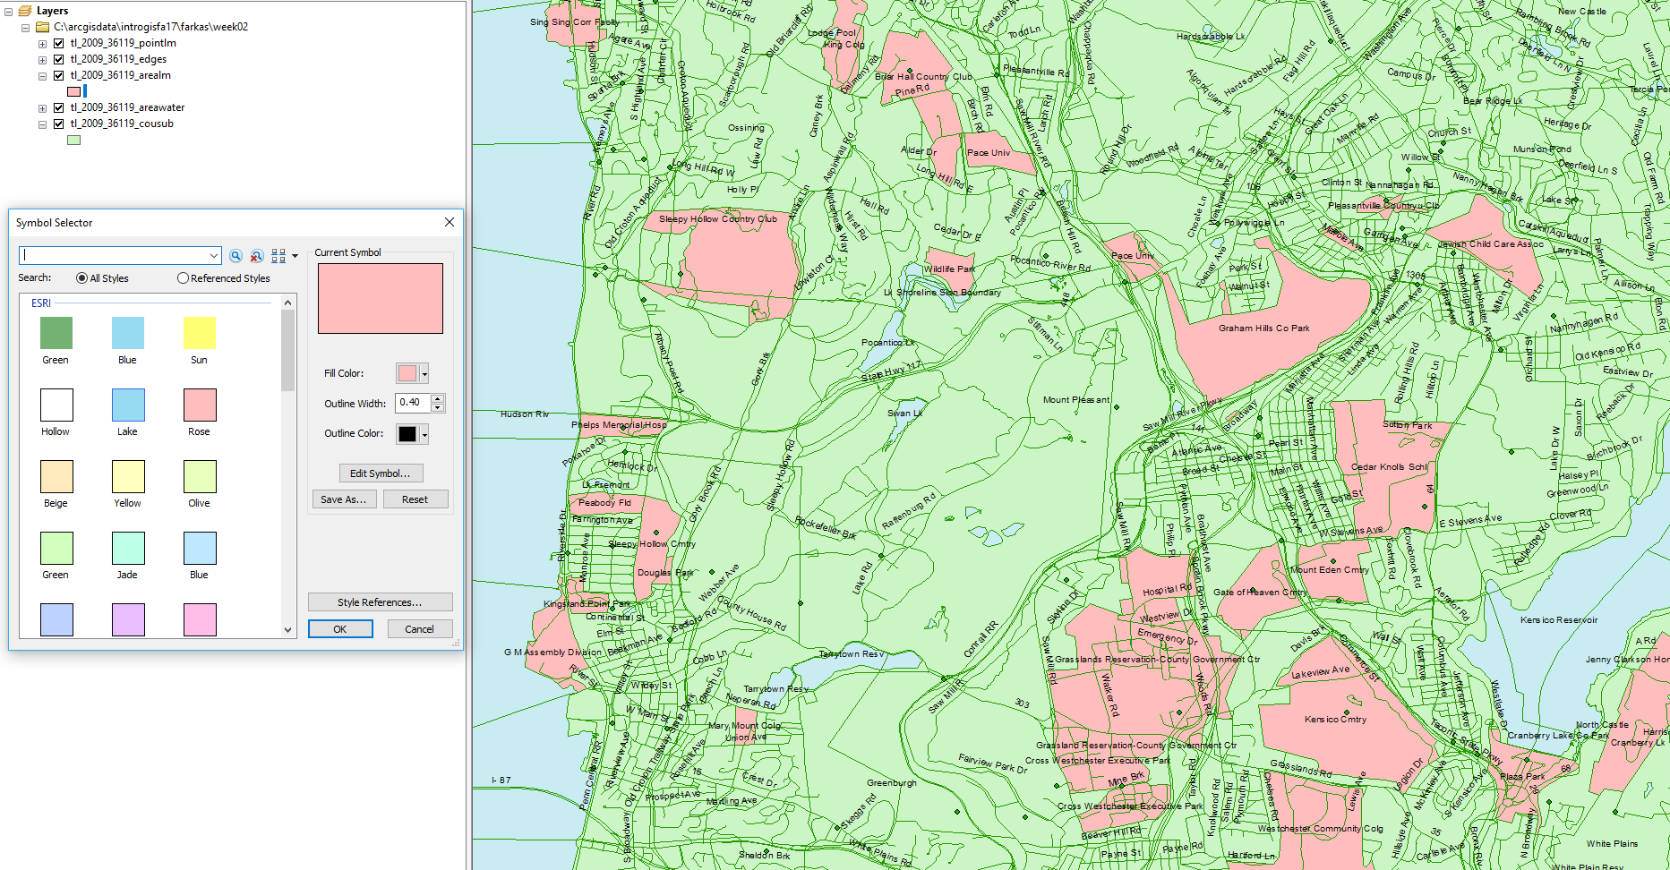

1. When see Pace and Graham Hills Park, export the map as a JPEG (File 🡪 Export Map) in your folder (yourlastnameWeek02Westchester02)
2. Save the map (File->Save)

***Making the make ready for presentation (Introduction to Cartography)***

Two characteristics of a good map is that it informative and is visually appealing. Both characteristics are complex are disciplines of their own. We will spend most of the semester concentrating on the former. For the latter, it is important to be attentive to aesthetics (how the map looks) and it will be part of the grade. This includes clutter (e.g. labels and layers), color, level of zoom, etc.

1. In the current map, zoom out to the original “Extent” (the Globe icon).
2. It may be a bit cluttered if you turned on Labels. Roads are too dense to show well. Also, it’s a lot of layers to try to show on a single map.
   1. Turn off the Roads layer (edges)
   2. Turn off Area Landmark labels (arealm)

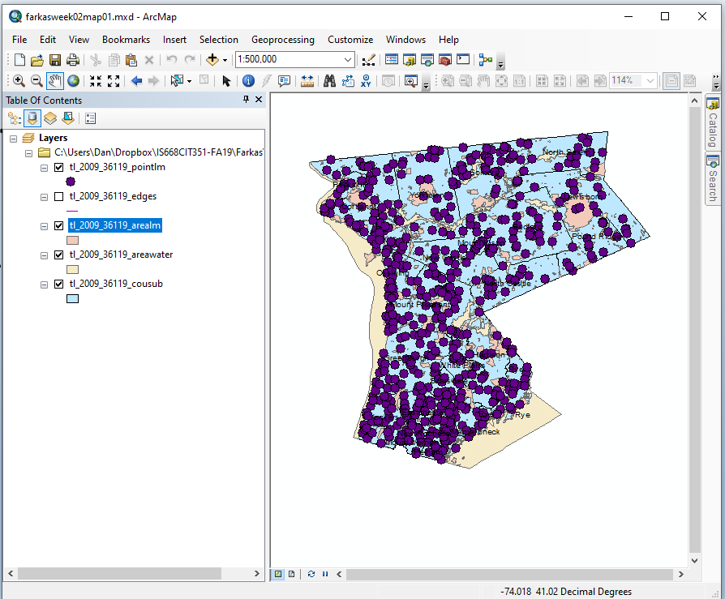

1. Switch to “Layout View” (View->Layout or second Icon at the bottom of the map panel)
2. Add a title: “Westchester Landmarks”
   1. Select Insert->Title
   2. A textbox comes up to enter the title. It will appear near the top of the map
   3. You can move it by hovering over the title and left mouse down.
   4. Add two more lines: Your name, the date
   5. Double-click the title and a dialog box opens up.
   6. Override the encoding with a complete 3 line title and click “OK”:

Westchester Landmarks

Your name

Date

1. Add a North Arrow (Insert->North Arrow)
   1. Choose one that you like
   2. Click Ok
   3. Move the North Arrow to a place that makes sense (e.g. upper right)
   4. Adjust the size by using one of the corners.
2. Add a legend (Insert -> Legend)
   1. Let the selected items default and select Preview (lower left)
   2. You will see the Legend on the map. Move it to an appropriate place (e.g., lower left) and use the corners to stretch or condense the size.
3. Add a scale bar (Insert ->Scale Bar)
   1. Click properties
   2. Change the Units to miles, click ok
   3. Select a Style, click ok
   4. Move and size the scale bar to an appropriate place (e.g., lower right or below the map)
4. Change the background color of the map
5. Export the map as a jpg (File->Export Map
   1. Name: yourlastnameWeek02Westchester03.jpg
6. Export the map as a pdf
   1. Name: yourlastnameWeek02Westchester03.pdf
7. Save the map

***Handing in the map images***

1. Create a Word document and “Insert” (a main menu item) the 3 JPEGs.
   1. Full extent exported map, Westchester01
   2. Zoomed in map of the Pace and Graham Hills Park, Westchester02
   3. The full-extent map in layout mode with Title, North Arrow, Legend and Scale Bar
   4. In Word, on the “Insert” tab, select “Picture” and insert the JPEGs
2. Name the Word Document: YourlastnameWeek02Westchester.doc

***Looking at the PDF layers***

1. Open up the pdf you created of your original map.
2. In the left panel there should be an icon of layers. Select it and in the expansion, further expand the “Layers”.
3. By clicking on the little “eyes”, you can turn off the layers.
4. This is a great way to share maps!

***Place the pdf and the Word document in the assignment link for this week’s folder***

**Due this Week:**

1. **Word Document with 3 map images**
2. **PDF of your Map in Layout View**

**Late Policy:**

1. This assignment is due Tuesday, 9/17 - 1 day grace period (Wednesday, 9/18)
2. The link is available until Wednesday, 9/18

**Getting Help**.

1. Before getting too frustrated – make sure you go through the “videos” which give step-by-step instructions.
2. Please use the Discussion Board to post and respond to questions. If you don’t get a response, please feel free to email me. Use the Forum: *IntroGIS – Questions and Comments*.